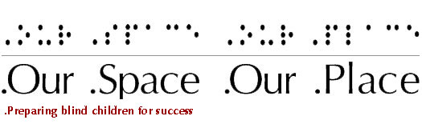

Summer 2009 Newsletter

Peer Mentoring

Further implementing our Mission, we created a peer mentor program this year. A student who completed our career exploration program and who expressed an interest in working with young people was hired to be our first peer mentor.

The student received a stipend and worked twice a month with the younger students. As a peer mentor, the student helped to distribute snacks, aided with the creation of art activities, participated in all of the after school programs and helped our adult volunteers to maintain the safety of the younger students.

Almost immediately we could see the impact of being a peer mentor. This student began to assume a leadership role in both groups. Her mother told us that this was exactly what her daughter needed to build her self esteem and her confidence. By the end of the year, the student was assisting Instructors in working with the other students. We look forward to her continuing to be a peer mentor.

Touch the Future: Career Exploration for Youth who are blind and their parents

This year we had five students participating in the career exploration program. Three of these students were interested in the music business. As a result, we took a tour of Cyber Sound, a recording studio in Boston. Mr. Geyer, the owner, gave us a tour of the recording studio, talked about the types of jobs available in a recording studio, the academic and professional background of people who work at a studio and the technology which is used. For some of our students, this was the first time they had visited a recording studio and the first time they learned about one aspect of the music business. One student shared a recording of a song she wrote.

We also invited professionals who are blind to share their experiences of pursuing employment. These presentations are available on our website: www.ourspaceourplace.org.

There were also activities which gave the students the opportunities to role play interviewing techniques and to develop their first resume. We used materials from the American Foundation for the Blind to allow our students to learn about the experiences of youth who are blind seeking their first job.

We continue to work on getting our parents engaged. We anticipate that next year, even more students will join this program.

Partnerships

We invited our partners to write summaries of our activities with them.

Visiting the Museum of Science
By Maria Cabrera, Community Relation Program Manager

The Our Space Our Place youth were a delight to have as our guests, throughout the 08-09 school year. The youth were divided into two groups, the pre-teens on Tuesdays and the teens on Thursdays. On Tuesdays, many areas of the Museum were explored from learning about planets to checking out Frogs and the Science in the Park exhibit where the throwing cage and the race strip was especially enjoyed. The teen group focused primarily in the Computer Clubhouse. They worked on learning several software programs like Scratch, but the real hit with them was the music studio. With the help of the Clubhouse volunteers and staff, they were able to make their own CDs to reflect their musical tastes. The Clubhouse was the ideal place for the teens to participate in, especially since it’s so well equipped with accessible computers and software.

A special thank you goes out to Jeffrey of OSOP and James of MOS who spent wonderful quality time with both groups. We are looking forward to another great collaboration in the coming school year!

Visiting the Museum of Fine Arts
By Valarie Burrows, Accessibility Coordinator

Now in its second year, the Museum of Fine Arts, Boston – Our Space/Our Place partnership introduces blind and low vision children and teens to art in a museum setting and provides an opportunity for self-expression through art-making activities.

The students began taking guided tours of the Museum’s spaces including tactile exploration of the Museum’s architectural elements and Please Be Seated Collection – more than 50 benches, chairs and settees created by American artists – and did simple, in-gallery art-making activities. To prepare students for the tactile exploration of original works of art using conservation gloves, the same objects were explored with one hand gloved and the other hand un-gloved so students were prepared for the different ways materials feel through cotton gloves. This spring, students were introduced to two dimensional works of art and self-portraiture. Through the exploration of the Museum’s permanent collections and temporary exhibits -- art of Ancient Egypt and Nubian, Asia, Art of the Americas, a temporary installation of more than 200 dollhouses, and the installation of gigantic sculptures of a baby’s head outside the museum -- the students created a wide range of art projects – three dimensional forms, collage, and paintings with both markers and acrylic paint.

Through this partnership and the MFA’s multi-sensory approach to presenting art, students learn that there are many ways to experience art and are encouraged to think about self-expression, in the galleries and through art-making. Building on tactile experiences and self-expression over time is a hallmark of the partnership.

The year-end celebration was held at the Museum of Fine Arts, Boston so that supporters and family members could see the work created by the students and experience a gallery tour to the Art of Ancient Egypt and Nubia.

Two of the students are attending Weekly Journeys in Art at the Museum this summer. We expect they may want to lead their own tours in the fall and hope they bring lots of new ideas to the 2009-2010 program.

Summer Activities

Although Our Space Our Place, Inc. does not operate during the summer, we wanted to share some of the activities that our students will be engaged in during this time.

Thanks to a generous donation, OSOP was able to sign two of our students up for art classes at the MFA. By participating in these classes, our students get a chance to meet new friends and to explore another way of expressing their ideas. OSOP strives to be an organization which helps our students to expand their known world.

One student, Nakia Stokes, had her art work sent to the MFA museum in Nagoya, Japan. The MFA has an art exchange program and will receive artwork of Japanese students later on in the year which will be displayed here in Boston. No one expected that Nakia's artwork would end up in an art museum in Japan. Nakia and her grandmother are thrilled. Along with her classmates’ art work, Nakia's piece, included below, has been displayed throughout the month of August.

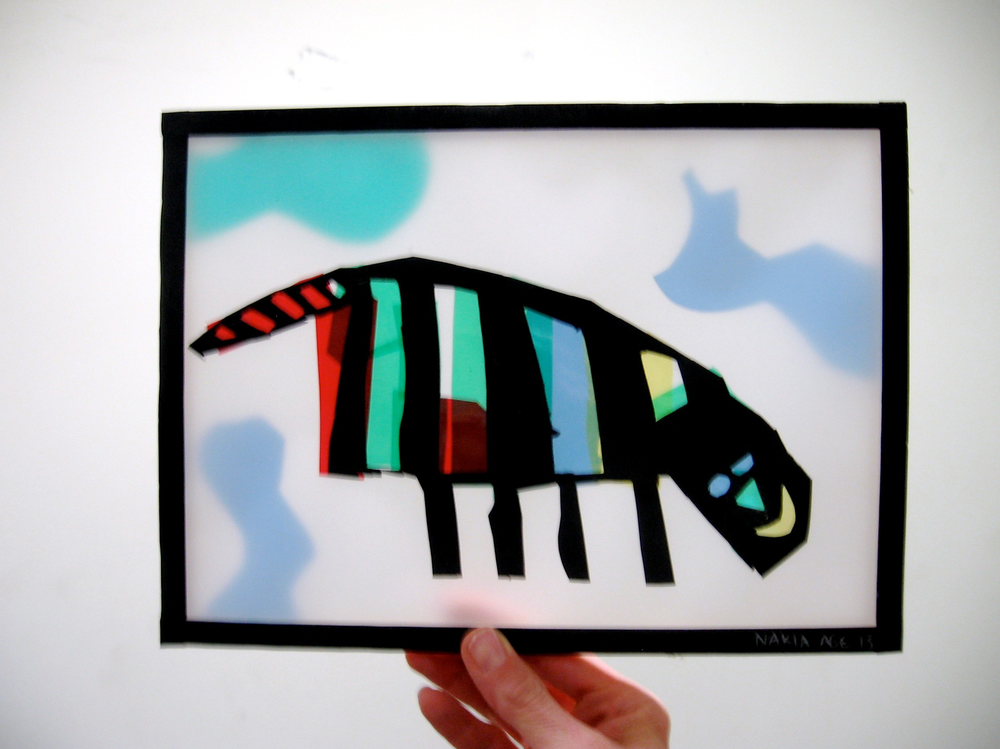

Another student is attending a multi week independent living program at Perkins School for the Blind. Through participating in the after school and career exploration programs, this student has become more willing to try new things. This is the first time this student will be away from home.

Two students will attend the summer program at the Carroll Center.

One student who completed the career exploration program will actively pursue searching for employment.

New Year: September 2009 – June 2010

Our new program year begins on Tuesday, September 22. We look forward to continuing our partnerships with the Museum of Fine Arts, the Museum of Science, the Wheelock Family Theatre, JapeScape Productions, the University of Massachusetts, Back and Forth Car Service and the Tobin Community Center. We are also exploring new opportunities with a martial arts studio, Tufts University, MIT and Outdoor Explorations.

Our career exploration program for elementary and high school students and their parents begins on Saturday, October 17 from 10:00 am – Noon at the Tobin Community Center. This program meets the third Saturday of each month until May. We look forward to an exciting year with new and continuing students.

Announcing OSOP 5 year Anniversary Auction: Building for the future

We just signed a contract with cMarket to conduct an on-line auction for OSOP in October. Our goal is to use this on-line auction to raise funds to support the on-going growth and programming of the organization. If you would like to be a Sponsor and/or donate an item to the auction, please let us know.

Funding
To ensure that we continue to offer programs which are accessible, fun and challenging, we need your assistance. You can donate to us on-line or by sending a check to:
Our Space Our Place, Inc.
198 Tremont Street Box 325
Boston, MA 02116

For more information about Our Space Our Place, Inc., please contact:
Cheryl Cumings, Executive Director
Email: president@ourspaceourplace.org
Phone: (617) 459-4084

We also welcome you to visit our Website and to enjoy the students’ latest radio show at www.ourspaceourplace.org.

If you know someone who would be interested in receiving this newsletter, or if you are interested in visiting Our Space Our Place, please reply to this email.

Our Mission
Our Space our Place, Inc., prepares blind youth for their future as productive adults by fostering the development of skills which enhance their self confidence, independence and self determination through activities which support social integration in their communities and the exploration of college and career opportunities.

Included below are recent photos of OSOP students playing outside in the park:

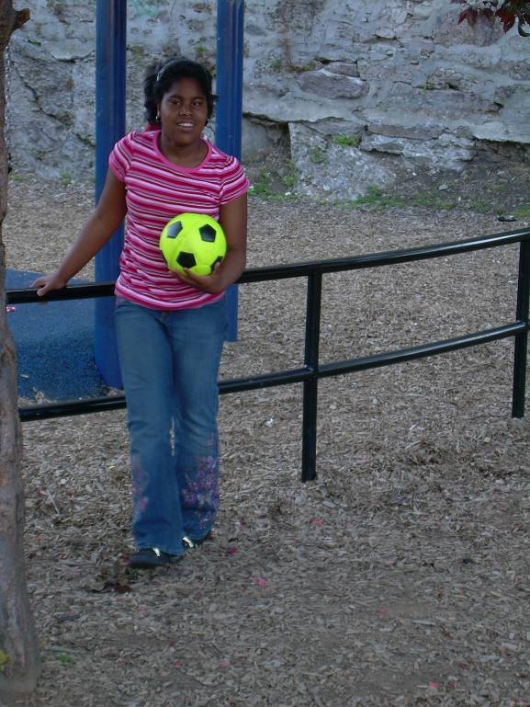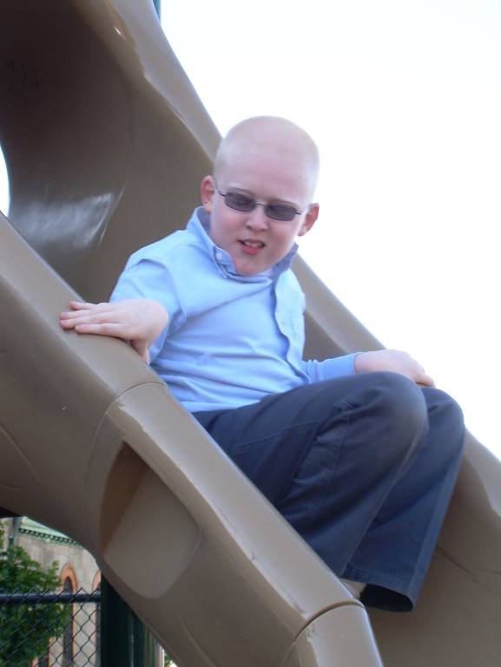

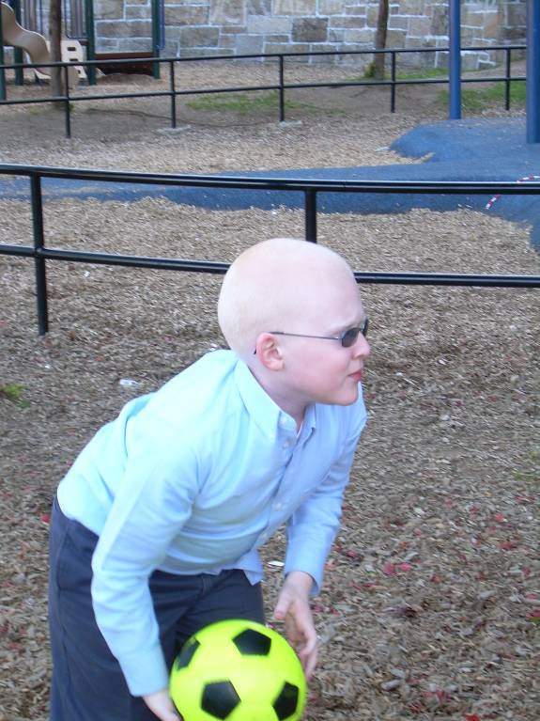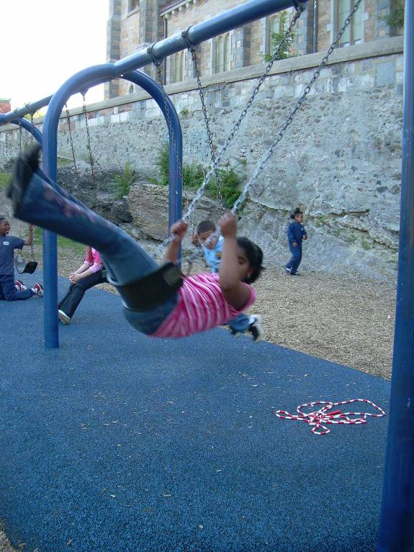

Included below are recent photos of students and an Instructor learning at the Museum of Science:



