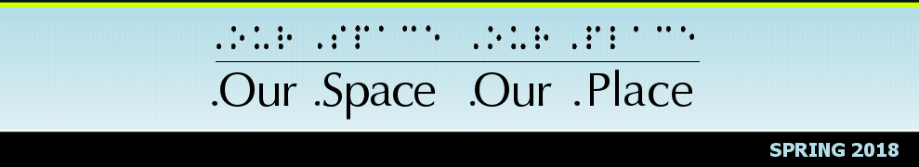

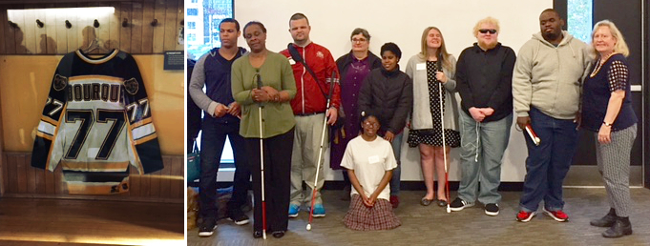
Our Space Our Place, Inc. programs help students increase their awareness of career options, build friendships, explore their potential, and develop independent living skills. The 2017–2018 school year is full of new partnerships, donors, volunteers and students.
This year, five new students ages 10–12 years old are attending Our Space Our Place. The students meet every Tuesday and get together with the older students, who meet every Thursday, to enjoy activities the first two Saturdays of the month.

Student Intern

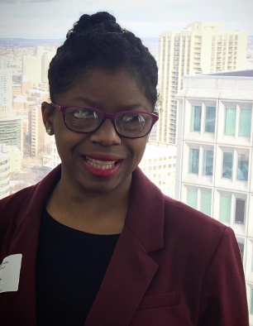
With your support, Mika Besson is realizing her goals of gaining experience to work with young students.
“My name is Mikaella Besson. I have been going to Our Space Our Place for about two years, and I am now working there as an intern as well. It has been a wonderful experience for me! On Tuesdays, I assist Cheryl with the students in different activities that are fun and educational for them and also allow them to make new friends. Some days we work on computer skills. On other days, we work on public speaking and theatre. Some days we go out in the community to places like the Museums of Science and Fine Art, Children’s Museum, Lego Land, and Create-A-Cook.
I’m very happy that I got this opportunity to work and be in this program! I enjoy working with younger students. I am also very fortunate to have Cheryl mentor me in this internship experience.”

Pursuing a Dream

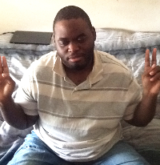
Carl Smith is another student who is realizing his goals. Carl participated in OSOP for seven years. Carl’s dream has always bene to become a DJ. He joined because he wanted to meet new people and to expand his life experiences.
“I was able to meet other blind students and so many new people who joined us as volunteers. I also enjoy all of the different places and things we do.”
Aware of Carl’s goals, when OSOP received a notice about training at the local radio station Boston Neighborhood Network (BNN), we shared that information and encouraged Carl to check it out. He contacted the station and joined a six-week class.
Today, Carl has an hour-long music show on the local BNN station. Carl’s show is in the evening; he plays all types of unfiltered music as DJ Castrawdis. Carl explains, “My goal is to get people to enjoy all types of music. If you listen to my show you will hear music from the 70s, 80s and on. You will hear rock and R&B.”
Link to radio show: http://bit.ly/2IaQp4G

Career Exploration: World of Careers
The 2017 World of Careers workshop was made possible by your generous contributions. It was held at District Hall, a local open space for startups and entrepreneurs. For some of the students, it was gratifying to learn about the availability of District Hall as a possible space for them to create their own products. For other students, they valued the opportunity to learn about daily aspects of work from others with disabilities.
The luncheon speaker James Breen, a graduate of Stonehill College, author, and motivational speaker living with CP, gave an inspirational talk sharing his life experience. James’ impact continued as he joined the students in a small group discussion talking more about steps he took to set up his own business.
Additionally, students talked about working in the arts and music fields, and discussed tangible actions for pursuing work in the health care field. Based on their feedback, the students valued the opportunity to hear from professionals and to share with each other their experiences of work.
As planning for the 2018 World of Careers workshop begins, the feedback from the participants will guide the structure of the day.
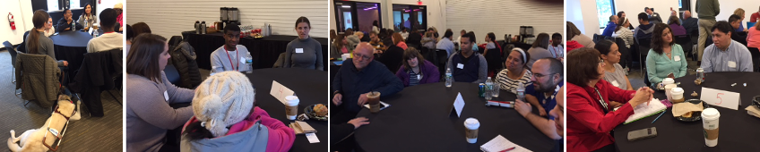

Upcoming Activities
- 5K Race, April 14
Continuing the OSOP tradition, the students are training for the Boston athletic Association 5K race, which is scheduled for Saturday April 14. To follow their progress, check out our Facebook page at: https://www.facebook.com/ourspaceourplace.
- Be.You.tiful Program: Empowering Girls, Breaking Barriers and Building Friendships, April 17, 18 and 19
Be.You.tiful is a 3-day workshop for girls with and without disabilities in middle and high school. This workshop gives students the opportunity to get to know each other, focusing on topics such as: succeeding academically and socially, what is beauty, healthy relationships, and who to turn to when it all feels like it is going wrong.
- Starting a New Phase of Life: How to Have a Successful Transition, End of April
This webinar is for students about to finish their transition. Students who have completed their transition share their experiences of what helped and what hindered their transition. The webinar is currently scheduled for the end of April. Stay tuned as we send out more detailed information.
- Coding Camp, Monday July 9- Friday July 13
Save the date for this amazing workshop. The workshop is for students in elementary and high school interested in learning about coding. Spend a week learning about HTML, CSS and JavaScript. At the end of the week, you will have met professionals working in technology and create your first webpage.

For more information or registration for the above activities, call OSOP at (617) 459-4084.

Become an Our Space Our Place Champion
You can make a significant difference in the access to opportunities for blind or low-vision students. Join the Champions and make a monthly donation. It’s very easy. Just go to our website, click the Donate button, and choose Monthly. Your contribution will ensure that blind or low-vision students have an after school program to attend.
Website: www.ourspaceourplace.org
